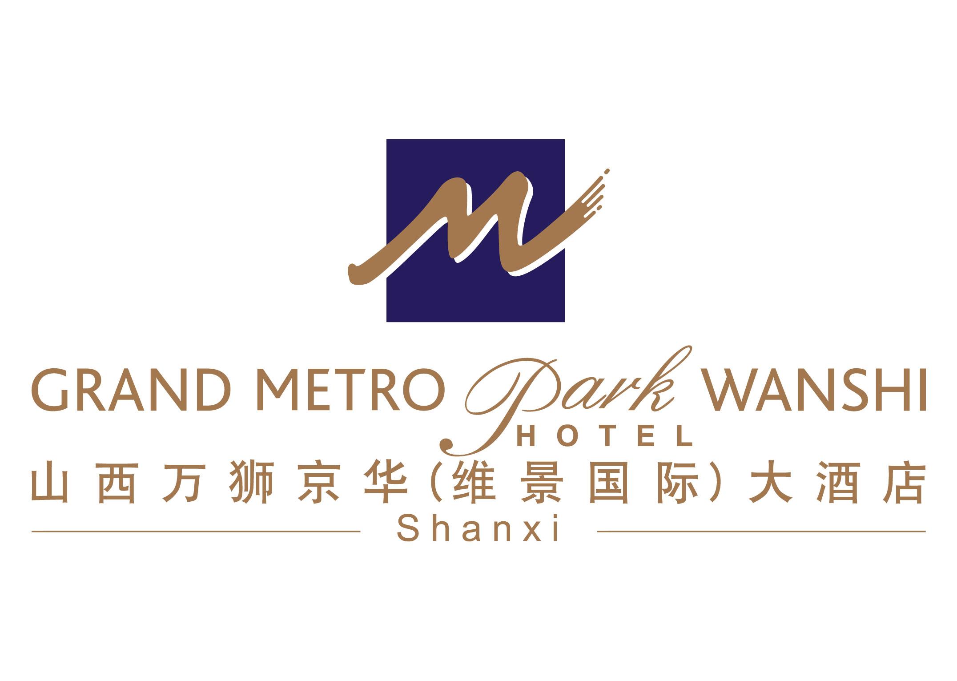

订房确认 Room Confirmation

收件人 Attention : 日期 Date :
公 司 Company :
由 From : Grand Metropark Wanshi hotel , Shanxi

感谢您选择山西万狮京华（维景国际）大酒店。我们很高兴地确认您及您的客户的房间预定, 如下：
Thank you for choosing Grand Metropark wanshi hotel, Shanxi. We are pleased to confirm your booking as follows.

客人姓名  Guest Name | 房间类型  Room Type | 房间数量  No. of Rooms | 抵店日期/时间  Arrival Date/Time | 离店日期/时间  Departure Date/Time | 房价（每晚）  Room Rate/Night

上述房价为净价，包含一份西式自助早餐，房间内免费宽带上网。
Above rate is net and including one breakfast, with free use of broadband internet in the room.

酒店的入住时间是下午2点，退房时间是中午12：00。对于没有担保的预订，我们将保留预订至入住当日的下午6点。对于担保的预订，如有变更，请于入住当日下午6点之前通知酒店；若预订未到，酒店将收取一晚的房费。
Please note the Check in time is 2pm and Check out time is 12:00 noon. Non guaranteed reservations will be held until 6pm. For guaranteed reservations, please provide any changes or cancellations prior to 6pm on the day of arrival in order to avoid one night’s cancellation charge.

再次感谢您下榻山西万狮京华（维景国际）大酒店作为您这次商务或旅游的目的地，我们热情地期待着您的到来！
We would like to thank you for selecting Grand Metropark wanshi hotel and we look forward to welcoming you.

谨此致上！
Kind Regards!

山西万狮京华（维景国际）大酒店
Grand Metropark wanshi hotel, Shanxi.

